

CITY MANAGEMENT
Request For Information
Unit and Tenant Information
To: Tenant Fit Out |  | RFI# |  | HMG-KAFD-RFI-ELE-010
 |  | Date |  | 26/02/2026
Tenant.fitout@kafd.sa |  | Tenant name |  |  | HMG
 |  | Building |  |  | 2.12
 |  | and Unit # |  |  | Retail 1, 2,3,4 & 5
RFI Description (Voltage Surge)
With reference to the regulations of the Saudi Electricity Regulatory Authority (SERA) and the attached document titled “Power Quality – SERA Regulatory Framework”

Power Quality

Please be informed that the standard nominal voltage in the Kingdom of Saudi Arabia is 230/400V (Single-phase 230V, Three-phase 400V).

As per SERA regulations, the permissible operating voltage range shall be as follows:

Single-phase: 218.5V to 241.5V

Three-phase: 380V to 420V

However, based on the site measurements and as clearly shown in the attached photographs, the recorded voltage values exceed the allowable limits specified by SERA and go beyond the normal acceptable voltage range in accordance with the above-mentioned regulatory framework.

This voltage deviation represents a non-compliance with SERA standards and may result in serious operational risks, including potential damage to sensitive medical equipment such as portable X-ray machines and other critical devices.

In light of the above, we kindly request your immediate guidance and necessary action to rectify this issue and ensure full compliance with SERA regulations.
Attachments:
Saudi Electricity Regulating Authority (SERA) | Photograph of measured voltages |  | Enhancement Drawing - KAFD
Submitted By:
Eng. Abdelrahman Kormod | HMG
Response To RFI (KAFD DMC)
Response By: | Name, Title |  | Date |  |  | Click or tap to enter a date.
 | Company

Attachments
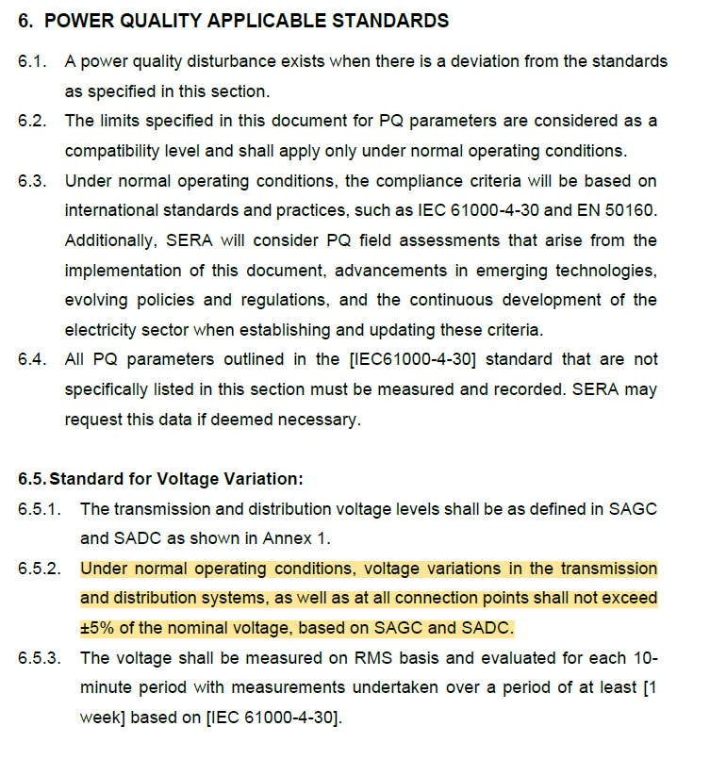

SERA - Standard Voltage level

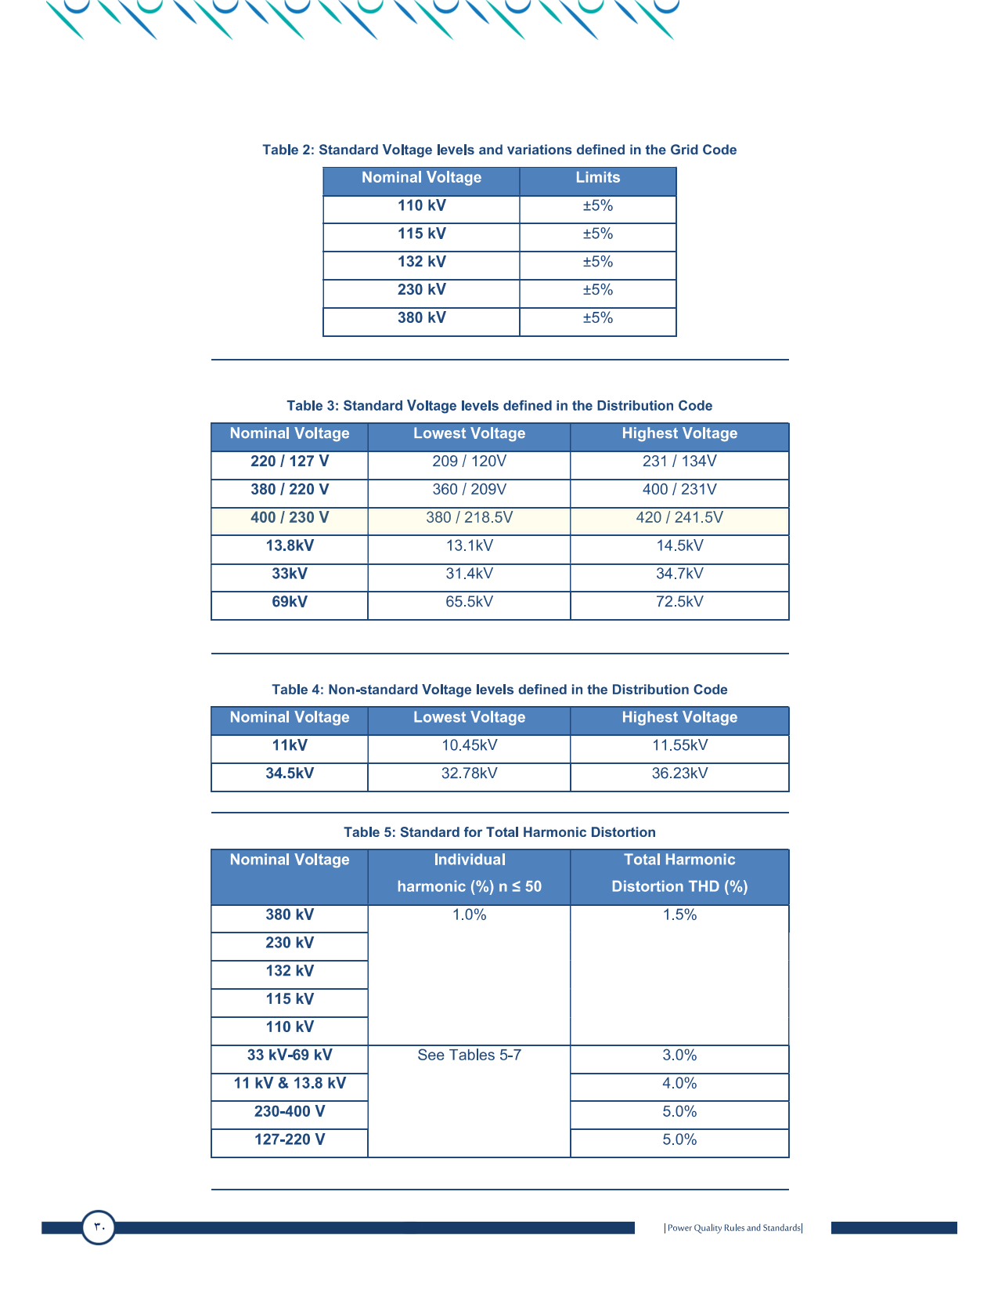

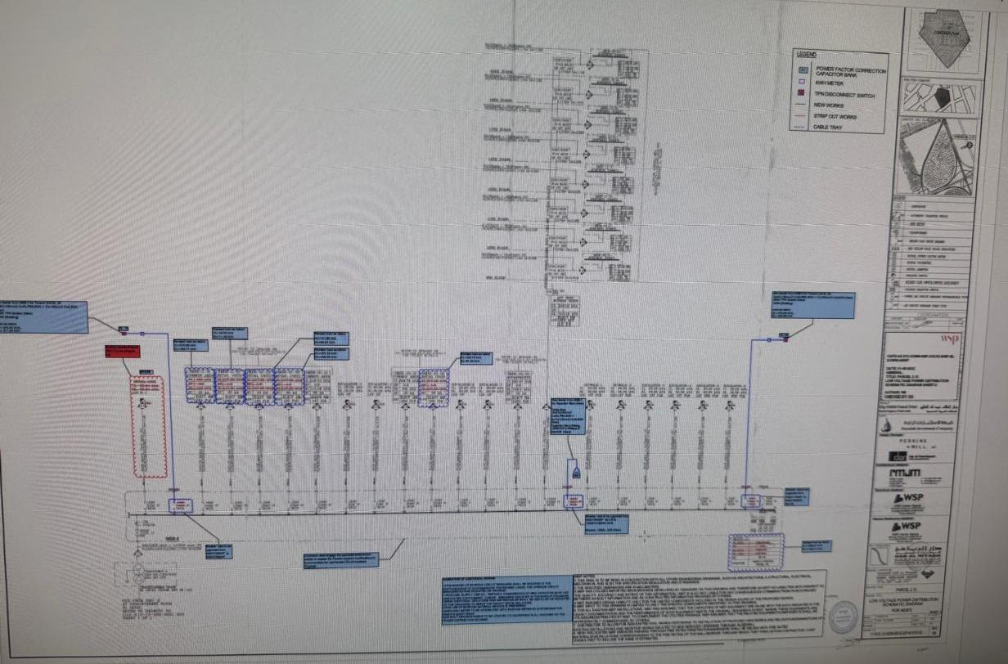
Enhancement Drawing - KAFD 2.12

Enhancement Drawing - KAFD 2.12
As per Enhancement drawing received from KAFD clearly mentioned supply voltage is 400V from Transformer-2, rating 2000 kVA, 13.8kV / 400V, 60Hz Dry Type.
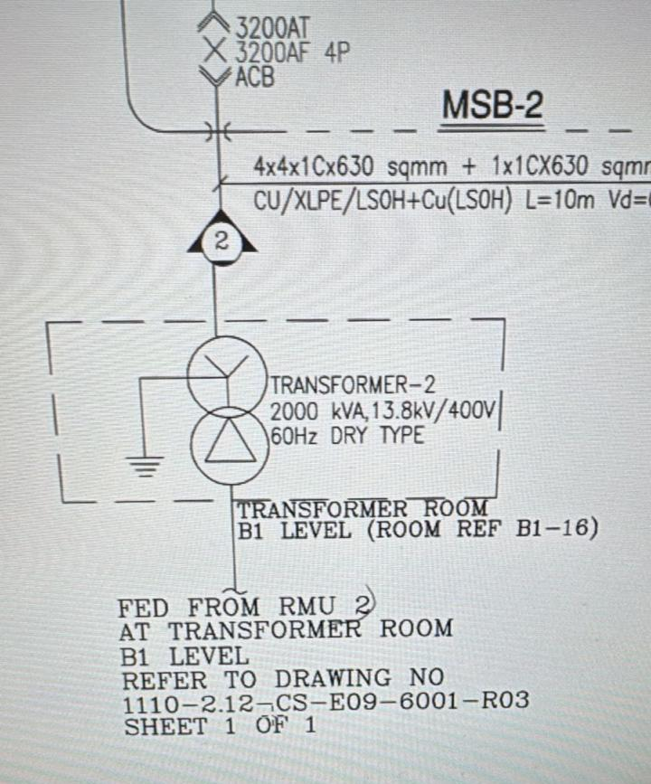

Measured Voltages in KAFD 2.12
Three-phase 438 V
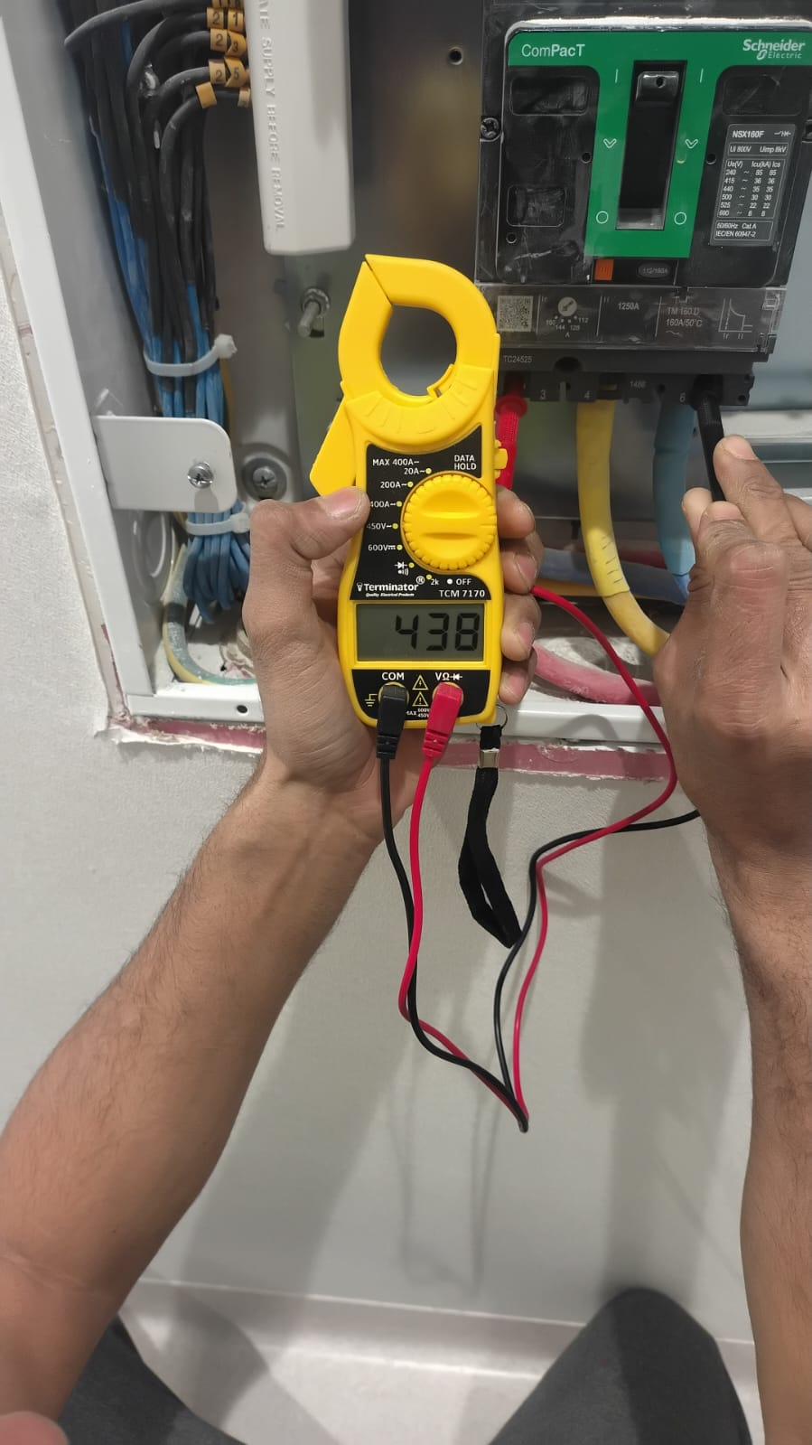
Measured Voltages in KAFD 2.12
Three-phase 437 V
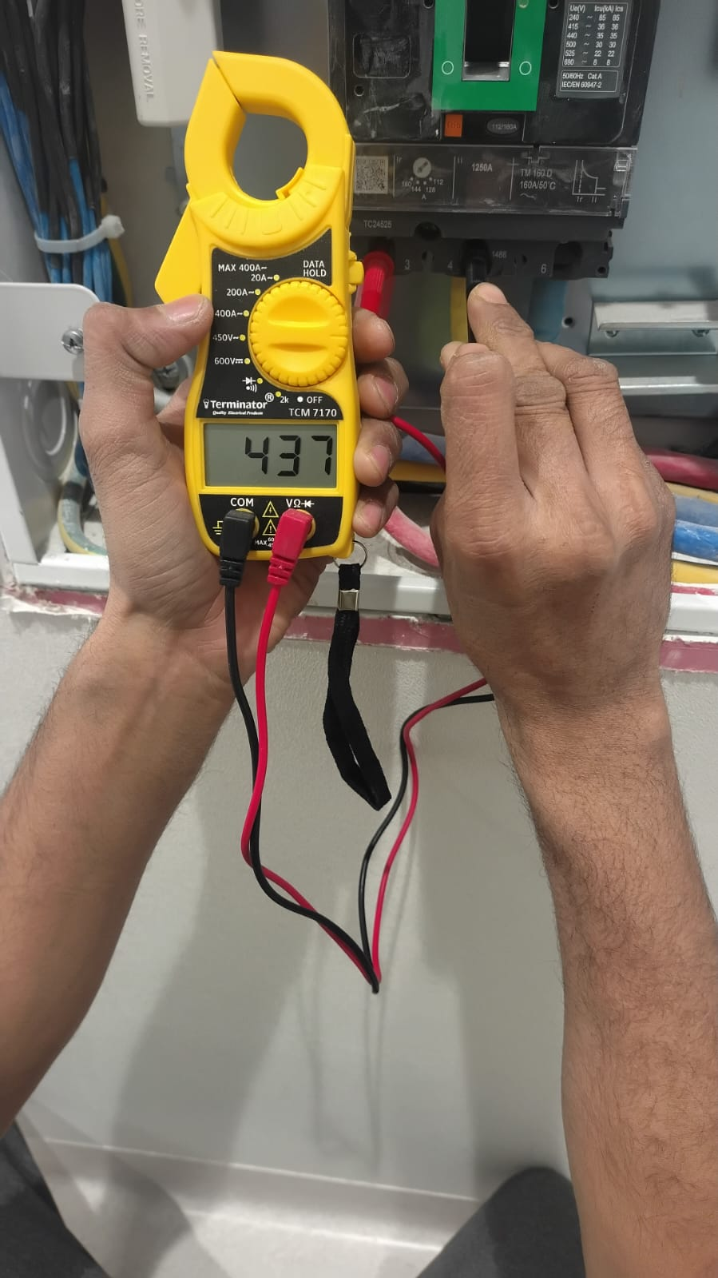
Measured Voltages in KAFD 2.12
Single-phase 246 V
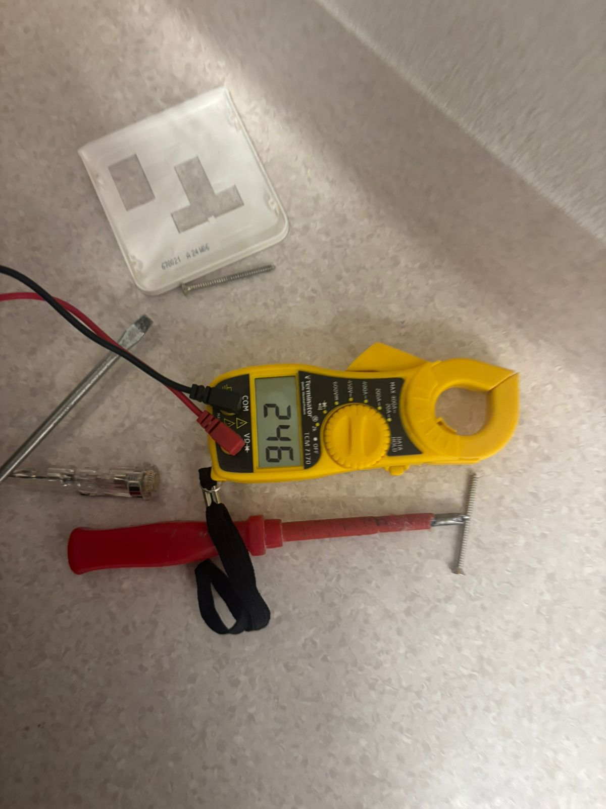

Measured Voltages in KAFD 2.12
Single-phase 245 V
